

SCHOOL OF COMPUTING

Department of Computer Science and Engineering

DATA ANALYSIS ESSENTIALS

CERTIFICATE

This is to certify that the Cornerstone project work entitled “FILE DATA ANALYZER” is submitted by
K.RAM CHARAN | (25B11CS387)
K.JASWANTH | (25B11CS349)
B.NIKHIL | (25B11CS676)
A.PRANAV ADITYA | (25B11CSA00)

in partial fulfillment of the requirements for the award of the B.Tech. degree in Computer Science and Engineering for the academic year 2026-2027.

Project Guide Head of the Department
K.Vydehi, Dr. Phani Sridhar Addepalli, Ph.D,
Assistant Professor, Assistant Professor,
Department of CSE Department of CSE

DECLARATION

We hereby declare that the Cornerstone project entitled “FILE DATA ANALYZER” is original and is submitted to ADITYA UNIVERSITY, Surampalem, in partial fulfillment of the requirements for the award of the B.Tech. Degree in Computer Science and Engineering. We further declare that this project work has not been submitted, either in full or in part, for the award of any degree in this or any other institution. We also confirm that this work complies with the Institutional Academic Integrity and AI Usage Policy

Place: Surampalem
Date:
By
K.RAM CHARAN | (25B11CS387)
K.JASWANTH | (25B11CS349)
B.NIKHIL | (25B11CS676)
A.PRANAV ADITYA | (25B11CSA00)

ACKNOWLEDGEMENT

It is with immense pleasure that we express our sincere gratitude to our Cornerstone Project Guide,K.VYDEHI, Assistant Professor, who has guided us throughout the project. Her valuable support, encouragement, and guidance have greatly contributed to the successful completion of this work.
We would like to thank our Deputy Heads of the Department, Dr. Chandra Sekhar Kolli, Associate Professor, Dr Hari Jyothula, Associate Professor and Dr Pennada Siva Satya Prasad, Assistant Profeesor, Department of Computer Science and Engineering, for their support and valuable suggestions.
Our deepest thanks to our Head of the Department Dr. Phani Sridhar Addepalli, Assistant Professor, for his inspiration and for providing all the necessary facilities and resources required for this project.
We also extend our sincere thanks to Dr. M.V. Rajesh, Associate Dean, School of Computing for their encouragement and support during the course of our project.
We would like to express our sincere gratitude to Dr. G. Suresh, Registrar, Dr. A Ramesh, Pro Vice-Chancellor (Engineering & Sciences), Dr. S. Rama Sree, Pro Vice-Chancellor (Academics), Dr. M.B. Srinivas, Vice-Chancellor, Dr. M. Sreenivasa Reddy, Deputy Pro Chancellor and Management, Aditya University for providing excellent infrastructure and state-of-the-art laboratories.
Finally, we would like to thank the faculty members, lab technicians, non-teaching staff, and our friends who have directly or indirectly supported us in completing this Cornerstone project successfully.

ABSTRACT
The File Data Analyzer System is a Python-based, menu-driven application designed to provide a common workflow for handling and analyzing multiple file formats. The supplied implementation supports CSV, Excel, JSON and TXT files. It provides Google Colab file upload, automatic file-format detection, dataset overview, dataset information, data preprocessing, statistical analysis, filtering, category analysis, numerical analysis, simple text-based visualization, TXT text analysis and batch processing. Tabular files are processed using Pandas and NumPy, while TXT files are handled with Python file operations and basic text statistics. The system maintains the currently loaded file and data and exposes its functionality through a console-based main menu. The project is intended for exploratory and descriptive analysis rather than predictive machine learning

TABLE OF CONTENTS
Section | Title | Page No.
Front Matter | Certificate | i
Front Matter | Declaration | ii
Front Matter | Acknowledgement | iii
Front Matter | Abstract | iv
Front Matter | Table of Contents | v
Front Matter | List of Figures | vi
Front Matter | List of Tables | vii
Chapter 1 | 1.1 Introduction to the Project | 1
Chapter 1 | 1.2 Problem Statement | 1
Chapter 1 | 1.3 Objectives of the Project | 1
Chapter 1 | 1.4 Scope of the Project | 1
Chapter 2 | 2.1 Dataset Source | 3
Chapter 2 | 2.2 Dataset Description | 3
Chapter 2 | 2.3 Key Features / Attributes | 3
Chapter 2 | 2.4 Dataset Statistics / Initial Exploration | 4
Chapter 3 | 3.1 Data Preprocessing | 4
Chapter 3 | 3.2 Preprocessing Strategy | 4
Chapter 3 | 3.3 Missing Values | 4
Chapter 3 | 3.4 Duplicate Removal | 4
Chapter 3 | 3.5 Date Conversion | 4
Chapter 4 | 4.1 Proposed Methodology | 6
Chapter 4 | 4.2 System Workflow / Architecture | 6
Chapter 4 | 4.3 Tools and Technologies Used | 7
Chapter 4 | 4.4 Design Characteristics | 7
Chapter 5 | 5.1 Development Environment | 9
Chapter 5 | 5.2 File Loading and Format Detection | 9
Chapter 5 | 5.3 File Inspection and Validation | 10
Chapter 5 | 5.4 Filtering and Statistical Analysis | 10
Chapter 5 | 5.5 Multiple File Processing and Summary Report | 11
Chapter 5 | 5.6 Data Visualization Implementation | 12
Chapter 5 | 5.7 File Selection and Main Menu | 13
Chapter 6 | 6.1 Sales Distribution – Histogram | 13
Chapter 6 | 6.2 Sales and Profit Comparison | 15
Chapter 6 | 6.3 Sales vs Profit Bar Comparison | 17
Chapter 6 | 6.4 Visualization Summary | 18
Chapter 7 | 7.1 Conclusion | 19
Chapter 7 | 7.2 Limitations | 20
Chapter 7 | 7.3 Future Enhancements | 20
LIST OF FIGURES

Figure 4.1: File Data Analyzer System Workflow
Figure 5.1: Google Colab File Upload and Automatic Detection
Figure 5.2: Dataset Overview and Information
Figure 5.3: Data Preprocessing
Figure 5.4: Statistical and Numerical Analysis
Figure 5.5: Filtering and Category Analysis
Figure 5.6: Text Visualization and Batch Processing
Figure 5.7: Main Menu Workflow

LIST OF TABLES

Table 2.1: Supported File Formats
Table 2.2: Core Modules and Functions
Table 4.1: Tools and Technologies Used
Table 5.1: Main Menu Operations
Table 6.1: Output Categories

CHAPTER 1 – INTRODUCTION

Introduction to the Project

Data files are commonly stored in different formats depending on their source and intended use. CSV and Excel files are widely used for tabular records, JSON is used for structured data exchange, and TXT files are useful for unstructured or semi-structured text. An analyst often needs to inspect, clean, summarize and analyze these files before using the information.
The File Data Analyzer addresses this requirement through one Python program. Instead of using separate utilities for every format, the program detects the file extension and invokes the corresponding reader. For tabular data it uses Pandas and NumPy operations; for TXT files it performs basic line, word and character analysis.

Problem Statement

Working with heterogeneous files manually requires repeated loading code and separate analysis routines. Users also need to inspect missing values and duplicate records before analysis. The project therefore aims to provide a single menu-driven system that accepts supported file types and exposes common inspection, preprocessing and analysis operations through a consistent interface.

• Provide a common entry point for CSV, Excel, JSON and TXT files.
• Automatically select the appropriate file-reading method.
• Inspect structure, data types, missing values and duplicate rows.
• Apply basic preprocessing to tabular data.
• Perform descriptive, categorical and numerical analysis.
• Support simple text analysis and batch processing.

Objectives of the Project

• Implement Google Colab file upload for convenient notebook execution.
• Use extension-based automatic file detection.
• Provide reusable functions for each supported file format.
• Provide dataset overview and information functions.
• Fill missing numerical values with median and categorical values with mode.
• Remove duplicate rows and convert date-related columns when possible.
• Provide statistical, filtering, category and numerical analysis.
• Provide a simple text-based distribution visualization.
• Analyze TXT files by lines, words and characters.
• Process multiple supported files in batch mode.
• Provide a menu-driven interface for major operations.

Scope of the Project

The project focuses on exploratory and descriptive data analysis rather than predictive machine learning. It covers local handling of CSV, Excel, JSON and TXT files. For tabular data it performs structural inspection, preprocessing, statistical, categorical and numerical analysis. For TXT files it reports basic text statistics. The
implementation can run in a Python environment and includes a Google Colab upload path.

CHAPTER 2 – DATASET DESCRIPTION AND UNDERSTANDING
This chapter describes the Superstore CSV used as the main demonstration dataset for the File Data Analyzer System. The dataset provides numerical, categorical and date-related fields for demonstrating file loading, preprocessing, filtering, statistical analysis and visualization.

The primary input dataset is the Superstore CSV dataset obtained from Kaggle. The project materials identify it as the main demonstration input with 9,994 records and 21 columns. The CSV is loaded using Pandas, with UTF-8 attempted first and latin1 used as a fallback.

2.2 Dataset Description
The Superstore dataset represents retail sales transactions. Each record contains information about an order, customer, product, geographical location, sales quantity, discount and profit. It is suitable for the File Data Analyzer because it contains numerical columns for statistics, categorical columns for filtering and aggregation, and date columns for preprocessing.

2.3 Key Features / Attributes
The dataset contains 21 attributes. The main attributes used by the current implementation are Sales, Quantity, Discount, Profit, Order Date, Ship Date, Category, Region and Segment.
Attribute | Description
Row ID | Record identifier
Order ID | Order identifier
Order Date | Order date
Ship Date | Shipping date
Ship Mode | Shipping method
Customer ID | Customer identifier
Customer Name | Customer name
Segment | Customer segment
Country | Country
City | City
State | State
Postal Code | Postal code
Region | Geographical region
Product ID | Product identifier
Category | Product category
Sub-Category | Product sub-category
Product Name | Product name
Sales | Sales amount
Quantity | Quantity sold
Discount | Discount applied
Profit | Profit amount

2.4 Dataset Statistics / Initial Exploration
Initial project inspection reports 9,994 records and 21 attributes. The project materials report 0 missing values and 0 duplicate rows for the Superstore input. Important numerical fields are Sales, Quantity, Discount and Profit, while Order Date and Ship Date are date-related fields.
Item | Value
Records | 9,994
Attributes | 21
Missing values | 0
Duplicate rows | 0
Important numerical fields | Sales, Quantity, Discount, Profit
Date fields | Order Date, Ship Date

CHAPTER 3 – DATA PREPROCESSING
The preprocessing stage prepares the input file for analysis. The current implementation removes structural problems, standardizes column names, converts valid date fields and records data-quality information.

3.1 Preprocessing Strategy
The preprocessing function removes completely empty rows and columns, trims whitespace from column names, identifies likely date columns, converts valid date values with pandas.to_datetime(), removes exact duplicate rows, and records missing-value information and final dimensions.

3.2 Empty Rows and Columns
Completely empty rows and columns are removed using dropna(axis=0, how='all') and dropna(axis=1, how='all').

3.3 Column Name Cleaning
Column names are converted to strings and stripped of leading and trailing whitespace so that later filtering, aggregation and visualization can use consistent names.

3.4 Date Conversion
Columns whose names indicate dates are checked automatically. For the Superstore dataset, Order Date and Ship Date are converted to datetime when at least 80% of their non-empty values are valid dates.

3.5 Duplicate and Missing-Value Validation
Exact duplicate rows are counted and removed. Missing values are counted and stored in the analysis report. For the Superstore dataset used in the project, both the missing-value count and duplicate-row count are reported as zero. The current implementation reports missing values rather than imputing them.

CHAPTER 4 – SYSTEM DESIGN AND METHODOLOGY
The system follows a sequential workflow: input file selection, format detection, file loading, inspection, preprocessing, analysis, filtering or aggregation, visualization and report generation.

4.1 Proposed Methodology
The proposed methodology separates file handling from analysis operations. The program first identifies the input format and loads the data. It then validates structure and data quality, preprocesses the data, performs descriptive and numerical analysis, and finally produces visual or summary outputs.

4.2 System Workflow / Architecture
Input File → Format Detection → File Loading → Inspection → Preprocessing → Analysis → Filtering / Aggregation → Visualization → Summary Report

4.3 Tools and Technologies Used
Technology | Purpose
Python | Core programming language
Pandas | Data loading, cleaning and analysis
NumPy | Numerical calculations
Matplotlib | Data visualization
glob | File discovery and batch processing
JSON | JSON file handling and report support
Google Colab | Interactive execution and file upload

4.4 Design Characteristics
The implementation is modular, reusable and menu-driven. It supports multiple input formats and uses a Superstore-specific analysis layer when the expected business columns are available.

CHAPTER 5 – IMPLEMENTATION
The implementation is a Google Colab-oriented Python system using Pandas, NumPy, Matplotlib and standard Python libraries. It provides separate functions for supported file types and a menu-driven workflow.

The system is implemented in Python and designed for Google Colab. Pandas handles data loading and manipulation, NumPy handles numerical operations, Matplotlib produces graphical visualizations, glob discovers files, JSON handles JSON data and os provides file utilities.

Code Listing 5.0 – Libraries and project configuration
import os
import glob
import json
import re
import numpy as np
import pandas as pd
import matplotlib.pyplot as plt
from google.colab import files
SUPPORTED_EXTENSIONS = [".txt", ".csv", ".json", ".xlsx", ".xls"]
SUMMARY_FILE = "file_analysis_summary.csv"
DATA_CACHE = {}
UPLOADED_FILES = []

5.2 File Loading and Format Detection
The system supports TXT, CSV, JSON and Excel files. get_extension() identifies the extension and load_file() calls the corresponding loader. CSV files are read with UTF-8 and latin1 fallback; Excel uses pandas.read_excel(); JSON uses the JSON module.
Code Listing 5.1 – File extension detection and file loading
def get_extension(filename):
"""
Returns the lowercase file extension.
"""
return os.path.splitext(filename)[1].lower()
def load_text_file(filename):
"""
Reads a TXT file.
"""
encodings = ["utf-8", "latin1"]
for encoding in encodings:
try:
with open(filename, "r", encoding=encoding) as file:
return file.read()
except UnicodeDecodeError:
continue
raise ValueError("Unable to decode text file.")
def load_csv_file(filename):
"""
Reads CSV using UTF-8 first and latin1 as fallback.
"""
try:
return pd.read_csv(filename, encoding="utf-8")
except UnicodeDecodeError:
return pd.read_csv(filename, encoding="latin1")
def load_json_file(filename):
"""
Reads JSON file.
"""
with open(filename, "r", encoding="utf-8") as file:
return json.load(file)
def load_excel_file(filename):
"""
Reads Excel file.
"""
return pd.read_excel(filename)
def load_file(filename):
"""
Loads a file according to its extension.
Uses cache so the same file is not repeatedly loaded.
"""
filename = clean_filename(filename)
if filename in DATA_CACHE:
return DATA_CACHE[filename]
extension = get_extension(filename)
if extension == ".txt":
data = load_text_file(filename)
elif extension == ".csv":
data = load_csv_file(filename)
elif extension == ".json":
data = load_json_file(filename)
elif extension in [".xlsx", ".xls"]:
data = load_excel_file(filename)
else:
raise ValueError(
f"Unsupported file format: {extension}"
)
DATA_CACHE[filename] = data
return data

5.3 File Inspection and Validation
CSV processing reports file name, rows, columns, column names, missing values, duplicate rows and the number of numerical columns. The system also identifies numerical and categorical fields.
Code Listing 5.2 – CSV dataset inspection and validation
def csv_file_processing(filename):
"""
Processes only CSV files.
Shows dataset structure and constraints.
"""
print_separator()
print("CSV FILE PROCESSING")
print_separator()
if get_extension(filename) != ".csv":
print("Selected file is not a CSV file.")
return
df = load_file(filename)
print(f"File : {filename}")
print(f"Rows : {df.shape[0]}")
print(f"Columns : {df.shape[1]}")
print("\nColumn Names:")
for column in df.columns:
print(f"- {column}")
print("\nDataset Constraints:")
print(f"Missing Values : {int(df.isnull().sum().sum())}")
print(f"Duplicate Rows : {int(df.duplicated().sum())}")
numeric_columns = df.select_dtypes(
include=np.number
).columns.tolist()
print(f"Numeric Columns: {len(numeric_columns)}")

5.4 Filtering and Statistical Analysis
For the Superstore demonstration, filtering uses the Sales column and selects records where Sales is greater than mean Sales. Statistical analysis identifies numerical columns and displays descriptive statistics using pandas.DataFrame.describe().
Code Listing 5.3 – Data filtering
def data_filtering(filename):
"""
Filters a numeric column.
For the Superstore dataset, Sales > mean Sales is used.
"""
print_separator()
print("DATA FILTERING")
print_separator()
extension = get_extension(filename)
if extension not in [".csv", ".xlsx", ".xls"]:
print("Filtering requires a tabular file.")
return
df = load_file(filename)
if "Sales" not in df.columns:
numeric_columns = df.select_dtypes(
include=np.number
).columns.tolist()
if len(numeric_columns) == 0:
print("No numeric column available for filtering.")
return
column = numeric_columns[0]
else:
column = "Sales"
mean_value = df[column].mean()
filtered_df = df[df[column] > mean_value]
print(f"File : {filename}")
print(f"Column : {column}")
print(f"Mean Value : {mean_value:.2f}")
print(f"Filter Condition : {column} > {mean_value:.2f}")
print(f"Filtered Rows : {len(filtered_df)}")
if len(filtered_df) > 0:
print("\nFirst 5 Filtered Records:")
display(filtered_df.head())
Code Listing 5.4 – Descriptive statistical analysis
def statistical_analysis(filename):
"""
Performs descriptive statistical analysis only.
"""
print_separator()
print("STATISTICAL ANALYSIS")
print_separator()
extension = get_extension(filename)
if extension not in [".csv", ".xlsx", ".xls"]:
print("Statistical analysis requires a tabular file.")
return
df = load_file(filename)
numeric_df = df.select_dtypes(include=np.number)
if numeric_df.empty:
print("No numeric columns found.")
return
print(f"File : {filename}")
print(f"Rows : {df.shape[0]}")
print(f"Columns : {df.shape[1]}")
print("\nNumeric Columns:")
for column in numeric_df.columns:
print(f"- {column}")
print("\nDescriptive Statistics:")
display(
numeric_df.describe().round(3)
)

5.5 Multiple File Processing and Summary Report
The project can discover multiple supported files using glob and can generate a concise CSV summary containing file name, file type, rows, columns and word count. The current implementation does not include a separate grouped-aggregation function.
Code Listing 5.5 – Multiple-file discovery using glob
def multiple_file_processing():
"""
Finds and processes multiple supported files using glob.
Only a concise summary is printed.
Detailed operations are available through the individual
menu sections.
"""
print_separator()
print("MULTIPLE FILE PROCESSING USING GLOB")
print_separator()
file_list = get_files_using_glob()
if not file_list:
print("No supported files found.")
return []
print(f"Files Detected : {len(file_list)}")
for index, filename in enumerate(file_list, start=1):
print(
f"{index}. {filename} "
f"({get_file_type(filename)})"
)
return file_list
Code Listing 5.6 – Automatic CSV summary report
def create_summary_report(file_list):
"""
Creates a concise CSV report.
One row is generated for each input file.
"""
print_separator()
print("AUTOMATIC SUMMARY REPORT")
print_separator()
summary_data = []
for filename in file_list:
extension = get_extension(filename)
try:
data = load_file(filename)
file_type = get_file_type(filename)
rows = ""
columns = ""
words = 0
# ------------------------------------------------
# TXT
# ------------------------------------------------
if extension == ".txt":
rows = len(data.splitlines())
columns = ""
words = count_words_in_text(data)
# ------------------------------------------------
# CSV / Excel
# ------------------------------------------------
elif extension in [".csv", ".xlsx", ".xls"]:
rows = data.shape[0]
columns = data.shape[1]
words = count_words_in_dataframe(data)
# ------------------------------------------------
# JSON
# ------------------------------------------------
elif extension == ".json":
if isinstance(data, list):
rows = len(data)
elif isinstance(data, dict):
rows = len(data)
else:
rows = 1
columns = ""
words = count_words_in_json(data)
summary_data.append(
{
"File": filename,
"Type": file_type,
"Rows": rows,
"Columns": columns,
"Words": words
}
)
except Exception as error:
summary_data.append(
{
"File": filename,
"Type": get_file_type(filename),
"Rows": "Error",
"Columns": "Error",
"Words": "Error"
}
)
print(
f"Could not process {filename}: {error}"
)
summary_df = pd.DataFrame(summary_data)
summary_df.to_csv(
SUMMARY_FILE,
index=False
)
print(f"Report created : {SUMMARY_FILE}")
print(f"Files analyzed : {len(summary_df)}")
print("\nSummary:")
display(summary_df)
return summary_df

5.6 Data Visualization Implementation
The data_visualization() function uses Matplotlib. It selects Sales when available and generates a 30-bin histogram. When Sales and Profit are present, it also creates a Sales-and-Profit comparison using the first 100 non-missing records.
Code Listing 5.7 – Sales histogram and Sales–Profit visualization
def data_visualization(filename):
"""
Creates visualizations for numeric data.
For Superstore:
1. Sales histogram
2. Sales vs Profit comparison
"""
print_separator()
print("DATA VISUALIZATION")
print_separator()
extension = get_extension(filename)
if extension not in [".csv", ".xlsx", ".xls"]:
print("Visualization requires a tabular file.")
return
df = load_file(filename)
# --------------------------------------------------------
# Visualization 1: Histogram
# --------------------------------------------------------
numeric_columns = df.select_dtypes(
include=np.number
).columns.tolist()
if len(numeric_columns) == 0:
print("No numeric data available.")
return
preferred_column = (
"Sales"
if "Sales" in df.columns
else numeric_columns[0]
)
plt.figure(figsize=(8, 5))
plt.hist(
df[preferred_column].dropna(),
bins=30
)
plt.title(f"Distribution of {preferred_column}")
plt.xlabel(preferred_column)
plt.ylabel("Frequency")
plt.tight_layout()
plt.show()
print(f"Histogram generated for: {preferred_column}")
# --------------------------------------------------------
# Visualization 2: Sales vs Profit
# --------------------------------------------------------
if "Sales" in df.columns and "Profit" in df.columns:
sample_df = df[
["Sales", "Profit"]
].dropna().head(100)
plt.figure(figsize=(8, 5))
plt.bar(
range(len(sample_df)),
sample_df["Sales"],
label="Sales"
)
plt.plot(
range(len(sample_df)),
sample_df["Profit"],
label="Profit"
)
plt.title("Sales and Profit Comparison")
plt.xlabel("Record Index")
plt.ylabel("Value")
plt.legend()
plt.tight_layout()
plt.show()
print("Sales vs Profit visualization generated.")

5.7 File Selection and Main Menu
The file-selection function lets the user choose one detected file, while show_menu() presents the available operations. Google Colab upload is handled through files.upload().
Code Listing 5.8 – File selection and menu interface
def select_file(file_list):
"""
Lets the user select one file.
"""
if not file_list:
print("No files available.")
return None
print_separator()
print("SELECT FILE")
print_separator()
for index, filename in enumerate(file_list, start=1):
print(
f"{index}. {filename} "
f"[{get_file_type(filename)}]"
)
while True:
try:
choice = int(input("\nEnter file number: "))
if 1 <= choice <= len(file_list):
return file_list[choice - 1]
print("Please enter a valid number.")
except ValueError:
print("Please enter a number.")
def show_menu():
print_separator()
print("FILE DATA ANALYZER SYSTEM")
print_separator()
print("1. Text File Processing")
print("2. CSV File Processing")
print("3. JSON File Processing")
print("4. Excel File Processing")
print("5. Word Count")
print("6. Data Filtering")
print("7. Statistical Analysis")
print("8. Multiple File Processing using glob")
print("9. Data Visualization")
print("10. Generate Summary Report")
print("0. Exit")

CHAPTER 6 – DATA VISUALIZATION AND RESULTS
This chapter presents the actual visualization outputs generated by the File Data Analyzer using the Superstore CSV dataset. The screenshots are taken from the project's Google Colab execution and correspond to the data_visualization() implementation.

6.1 Sales Distribution – Histogram
The first visualization is a histogram of the Sales attribute. The code divides Sales values into 30 bins. The x-axis represents Sales values and the y-axis represents frequency.
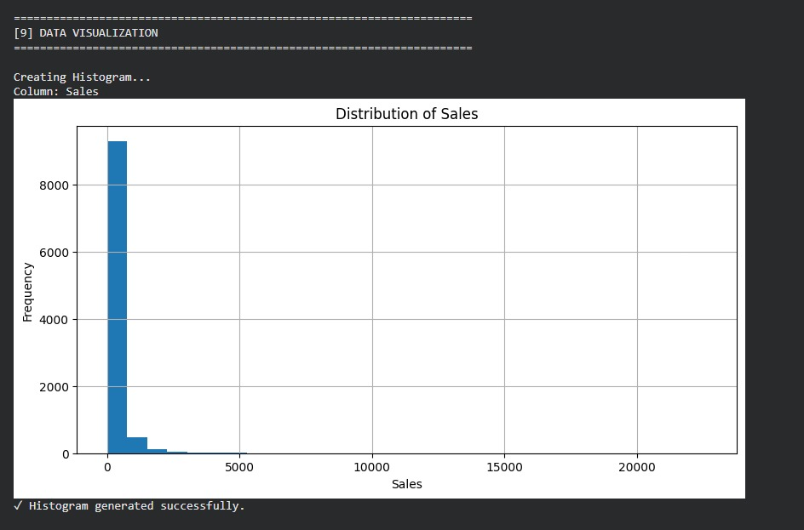
Figure 6.1: Distribution of Sales generated by the File Data Analyzer
Result: The histogram shows a large concentration of observations at relatively lower Sales values, with fewer observations extending toward much larger Sales values. This indicates a right-skewed Sales distribution.

6.2 Sales and Profit Comparison
The second visualization compares Sales and Profit for the first 100 non-missing records. Sales are shown as bars and Profit as a line, with record index on the x-axis.
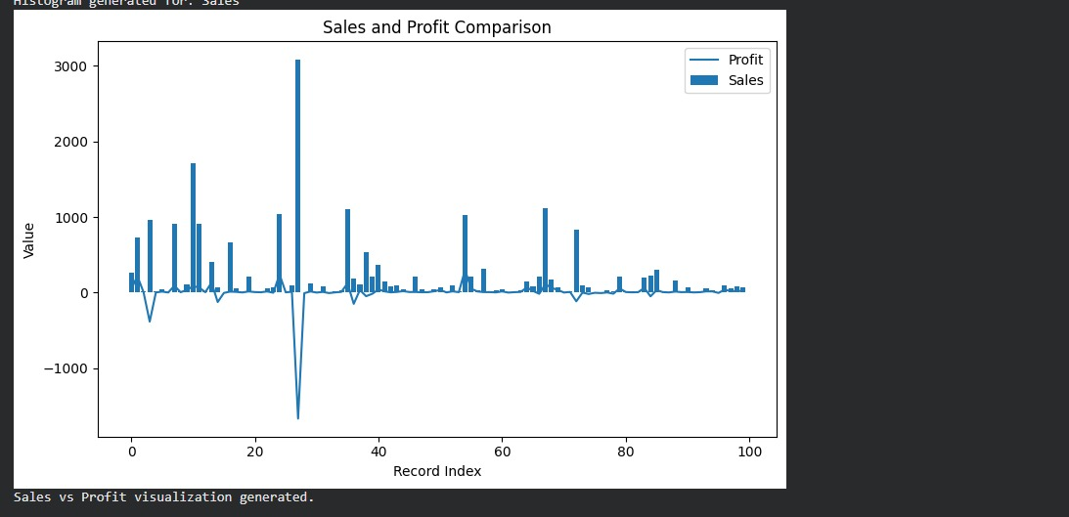
Figure 6.2: Sales and Profit comparison for the first 100 records
Result: The output contains both positive and negative Profit values. Several records have large Sales values while Profit varies considerably. This demonstrates that high Sales do not automatically imply high Profit.

6.3 Sales vs Profit Bar Comparison
The third visualization presents Sales and Profit for ten displayed records as a bar comparison. It provides a compact view of the difference in magnitude and sign between the two numerical attributes.
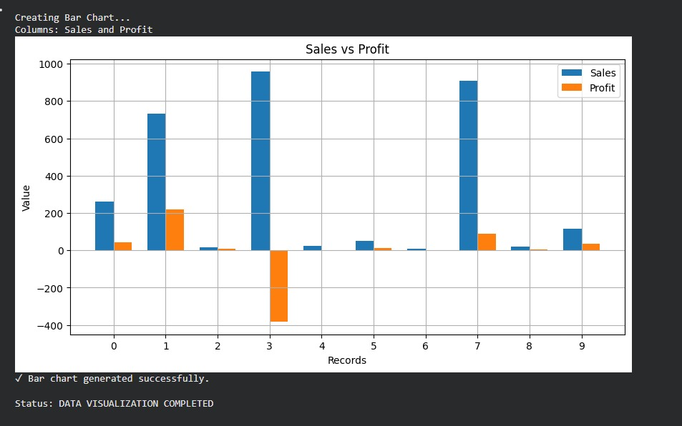
Figure 6.3: Sales vs Profit bar comparison
Result: Sales remain positive in the displayed records, while Profit can be positive or negative. The negative Profit observation demonstrates that a transaction may generate sales while still producing a loss.

6.4 Visualization Summary
Visualization | Attribute(s) | Purpose
Histogram | Sales | Shows the frequency distribution of Sales values.
Sales and Profit comparison | Sales, Profit | Compares sales magnitude with profit variation across records.
Bar comparison | Sales, Profit | Compares Sales and Profit values for displayed records.
The visualizations are generated directly from the Superstore input by data_visualization() using Matplotlib.

CHAPTER 7 – CONCLUSION AND FUTURE ENHANCEMENTS
The File Data Analyzer System provides a reusable workflow for loading, inspecting, preprocessing, filtering, statistically analyzing and visualizing data files. The current implementation supports TXT, CSV, JSON and Excel inputs and uses Pandas, NumPy and Matplotlib for data processing and visualization.

The Superstore CSV is used as the main demonstration dataset. The project demonstrates Sales distribution analysis and Sales-versus-Profit visualization, with the actual execution outputs documented in Chapter 6.

7.2 Limitations
• Visualization currently focuses on numerical data and the Superstore Sales/Profit demonstration.
• The Sales-versus-Profit comparison uses the first 100 non-missing records.
• Missing values are reported rather than automatically imputed.
• Superstore-specific analysis depends on expected column names such as Sales, Quantity, Discount and Profit.

7.3 Future Enhancements
• Add interactive dashboards and additional chart types.
• Add category-wise and region-wise graphical summaries.
• Add configurable aggregation for large datasets.
• Add automatic chart export and report generation.
• Add advanced missing-value handling, outlier detection and correlation analysis.

REFERENCES
- McKinney, Wes. Python for Data Analysis: Data Wrangling with pandas, NumPy, and Jupyter, 3rd Edition, O'Reilly Media, 2022.
- McKinney, Wes. Python for Data Analysis: Data Wrangling with Pandas, NumPy, and IPython, 2nd Edition, O'Reilly Media, 2017.
- VanderPlas, Jake. Python Data Science Handbook: Essential Tools for Working with Data, 2nd Edition, O'Reilly Media, 2022.
- Müller, Andreas C., and Sarah Guido. Introduction to Machine Learning with Python: A Guide for Data Scientists, O'Reilly Media, 2016.
- McKinney, Wes. Python for Data Analysis — particularly the sections covering data loading, cleaning and preparation, visualization, and data aggregation, which are closely related to the operations implemented in this project.

